EXPERIMENT NO -14: APHA & BETA ALGORITHM
Aim
To implement the Alpha-Beta Pruning algorithm for gaming using Prolog. Alpha-Beta pruning improves the Minimax algorithm by eliminating branches that cannot affect the final decision.
Algorithm
- Represent the game tree using nodes and leaf values.
- Start with:
  - Alpha = -∞
  - Beta = +∞
- At a MAX node, select the maximum value.
- At a MIN node, select the minimum value.
- Update Alpha at MAX nodes.
- Update Beta at MIN nodes.
- If Alpha >= Beta, prune the remaining branches.
- Continue until the best value for the root node is obtained.
- Display the optimal value.
Python Code
def alpha_beta(depth, node, maximizing, values, alpha, beta):
# Leaf node
if depth == 3:
return values[node]

if maximizing:
best = -9999

for i in range(2):
value = alpha_beta(depth + 1, node * 2 + i,
False, values, alpha, beta)

best = max(best, value)
alpha = max(alpha, best)

# Beta cut-off
if beta <= alpha:
break

return best

else:
best = 9999

for i in range(2):
value = alpha_beta(depth + 1, node * 2 + i,
True, values, alpha, beta)

best = min(best, value)
beta = min(beta, best)

# Alpha cut-off
if beta <= alpha:
break

return best

# Leaf node values
values = [3, 5, 6, 9, 1, 2, 0, -1]

alpha = -9999
beta = 9999

result = alpha_beta(0, 0, True, values, alpha, beta)

print("Optimal value:", result)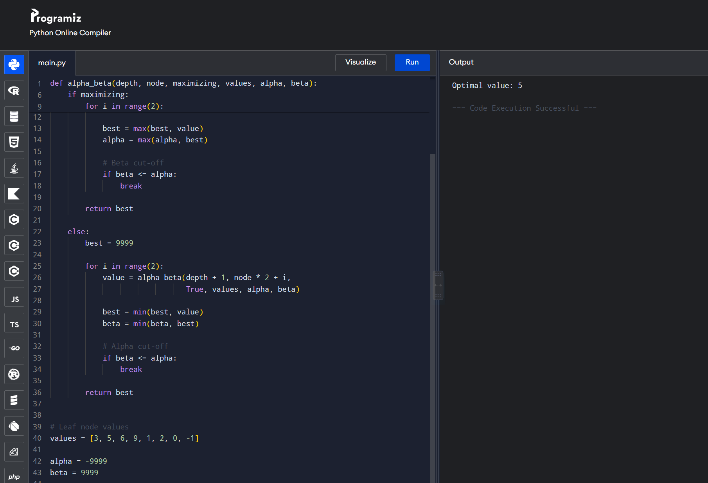
Result
Thus, the Alpha-Beta Pruning algorithm was successfully implemented in Prolog. The algorithm evaluates the game tree and prunes unnecessary branches while finding the optimal value.

